# 2018 06 27 optimization testing

Note: I believe these numbers are all local testing 2018 10 - Andrew

Running with last 10 minutes of data in one day

* Total: 3:50
* Most steps take 3-10 seconds
* Copying the dataset to work takes by far the most time
  + 17 seconds for nbbo
  + 1:30 for quotes

Initial results. I want to make sure I can replicate this table

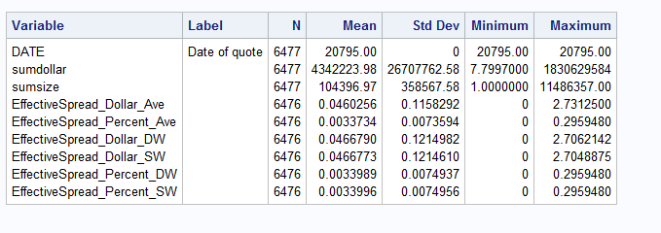

After merging several data steps, total time is 3:00.

After merging some more steps: 2:50. Seems like we have diminishing returns.